**Experiment 7: App Layout Creation using GIMP**

**SHERYL KATRINA M**

**23070310**

**Aim:**

To create and analyze an e-commerce app homepage layout using GIMP, focusing on structured sections, visual balance, typography, and color dynamics to deliver a realistic shopping experience.

**Tools Used:**

GIMP (GNU Image Manipulation Program

**Procedure:**

**Step 1: Install GIMP**

* Download and install GIMP from the official website.

**Step 2: Create a New Project**

* Open GIMP and set up a new canvas with dimensions suitable for web (standard dimensions around 1200x800 pixels were used).

**Step 3: Designing the Layout**

1. **Header Section:**
   * Created a horizontal bar at the top.
   * Added the brand name "NOUS" on the left side using the Text Tool, simulating a typical brand logo placement.
   * On the right side, navigation links were inserted: "SHOP ALL," "ABOUT," and "CONTACT," maintaining simplicity and readability.
   * A small "greater than" (>) sign was added to imply additional navigation options.
2. **Promotional Banner:**
   * Below the header, a bold, eye-catching red banner was created.
   * Inserted the text "FREE SHIPPING" prominently in the center with a contrasting white font to ensure high visibility.
3. **Category Section:**
   * Directly under the red banner, another horizontal section was added.
   * This section was divided into three clickable category links: "WOMEN CLOTHING," "MEN CLOTHING," and "KID CLOTHING," spaced evenly across the width.
4. **Product Display Section:**
   * The lower half of the layout was split into two image sections.
   * Left side: Featured two models wearing hoodies, representing the "WOMEN" and "MEN" clothing categories.
   * Right side: Featured a close-up shot of another model in kid-friendly clothing, emphasizing a premium yet casual look.

**Step 4: Add UI Elements and Styling**

* All text was added using the Text Tool.
* Fonts were chosen to be modern and sans-serif to maintain a clean, sleek aesthetic.
* Used high-resolution images to maintain professional visual quality.
* All sections were aligned symmetrically to balance the visual flow.

**Step 5: Organize Layers**

* Each UI component (logo, navigation, banner, categories, images) was placed on separate layers.
* Layer naming conventions were followed for easier edits (e.g., "Header Text," "Banner Background," "Product Image 1").

**Step 6: Experiment with Color Schemes**

* Main colors:
  + White (background) for cleanliness.
  + Red (promotional banner) for urgency and attention.
  + Black (clothing) to convey luxury and simplicity.
* This minimalistic color scheme enhances focus on the products and promotional elements.

**Step 7: Export Final Design**

* The final layout was exported in PNG format for maximum compatibility and quality.

**Output Screenshot:**

*Designed Layout Screenshot:*

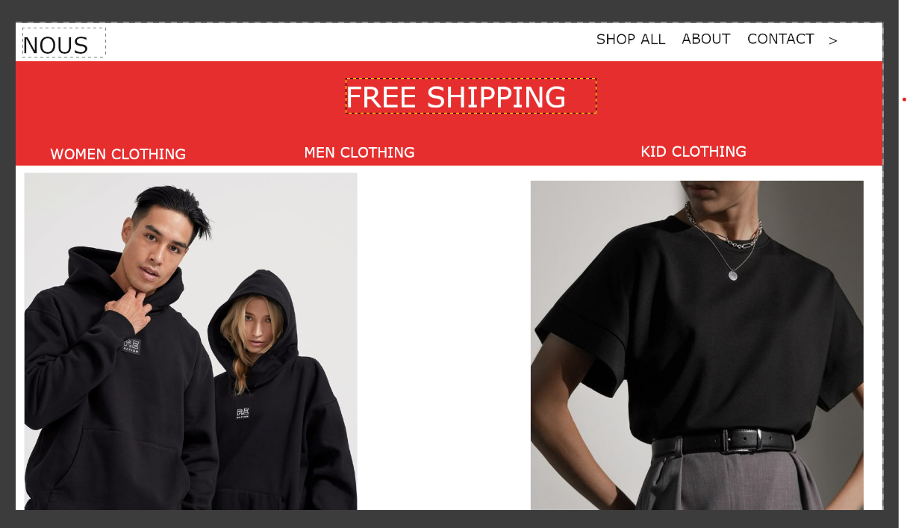

**Observations and Detailed Analysis:**

* **Brand Identity:** Clear and simple brand representation with the "NOUS" logo.
* **Navigation:** Minimal and direct, enhancing user experience without overwhelming them.
* **Visual Hierarchy:**
  + "FREE SHIPPING" banner strategically positioned for immediate user attention.
  + Category labels placed logically right below to guide users swiftly.
* **Product Presentation:**
  + Two models featured on the left, with casual, relatable poses enhance approachability.
  + Solo model on the right with a clean, modern outfit gives a sophisticated vibe.
* **Color Impact:**
  + The use of red contrasts against the white background to create urgency.
  + Black outfits balance the red, providing a grounded, professional look.
* **Usability:**
  + Clear sections allow users to intuitively navigate between shopping categories.
  + Visual simplicity reduces cognitive load.

**Google Form Feedback:**

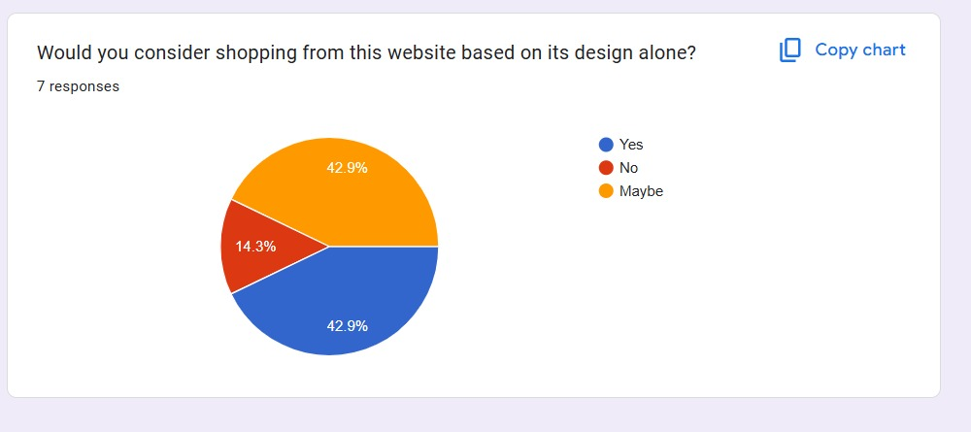

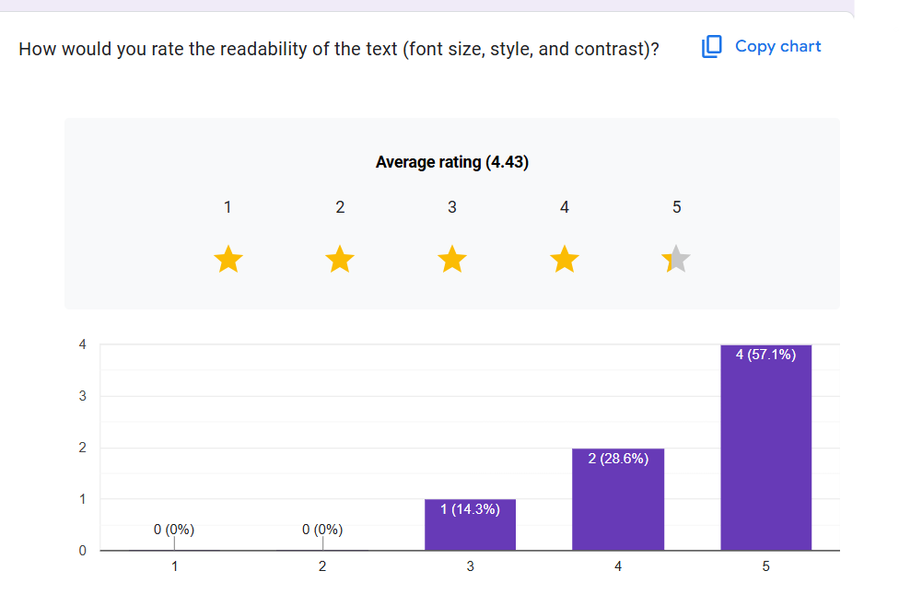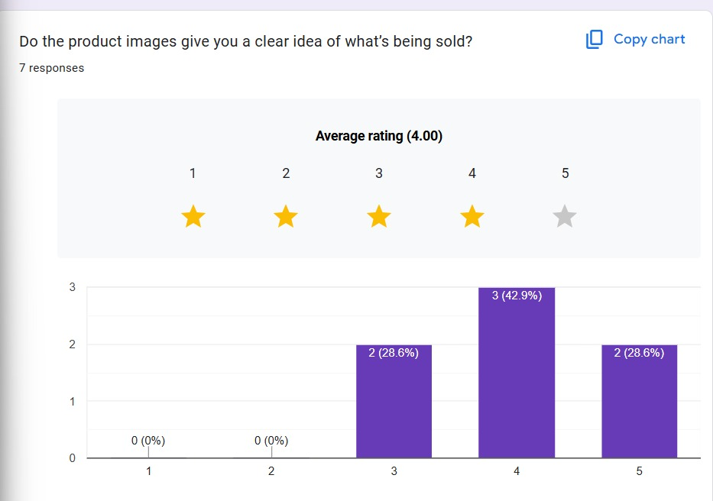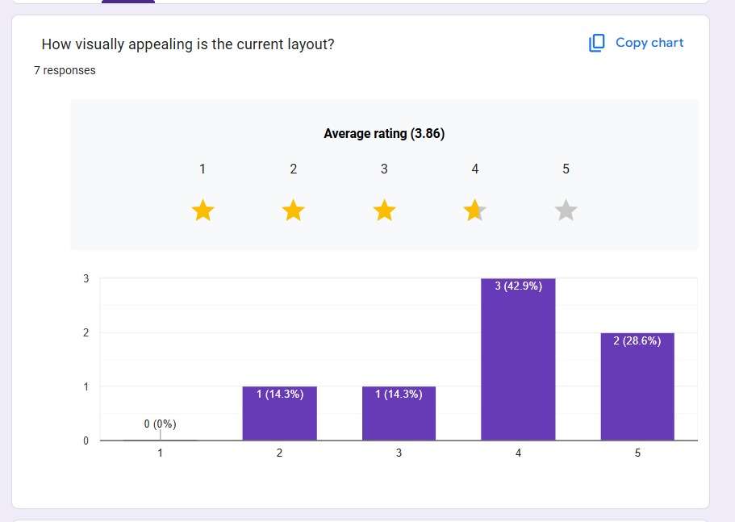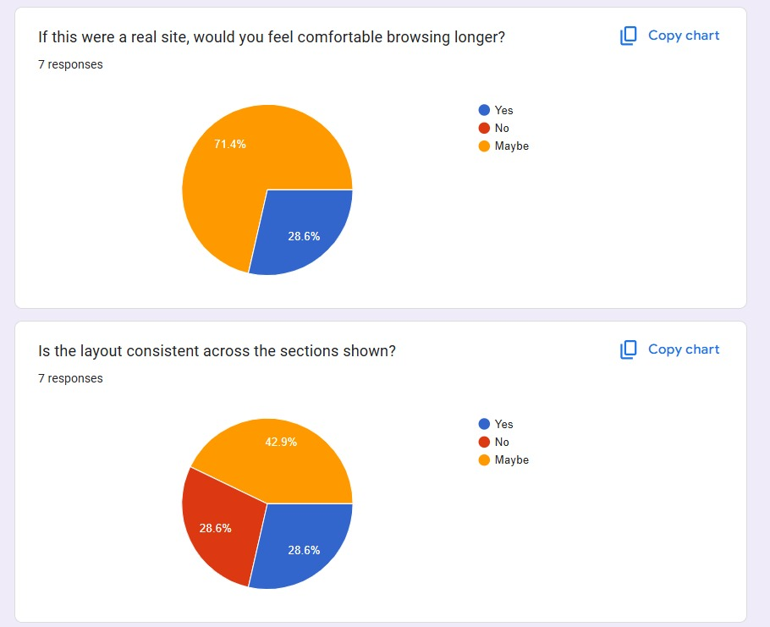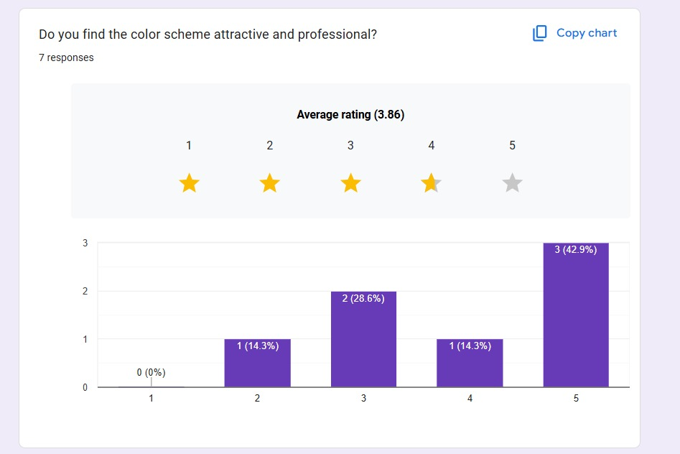



**Conclusion:**

This experiment successfully recreated a professional and appealing shopping homepage using GIMP. By thoughtfully structuring layout elements and choosing a restrained but powerful color palette, the design ensures excellent usability and visual engagement. GIMP proved to be an effective and accessible tool for rapid UI/UX prototyping, demonstrating its capabilities beyond just image editing.